Pacing Lab

In this lab, you will determine your own pace length. To do so, follow the instructions in the first part of the pacing and chaining power point presentation. You will need to mark out a length no shorter than 100 feet long, then you will need to pace that distance a minimum of 5 times to determine your average number of paces for that particular length. You will then calculate your individual pace length based on the previous steps. Once you have calculated your pace length answers the following questions:

- What distance would you have paced if you counted 547 paces on a flat plane?

- What distance would you have paced if you counted 149.5 paces on a flat plane?
- If you were walking up a hill that was inclined at a 45 degree angle, what would be your true level/ horizontal distance traveled if you counted 382 paces going up the incline?

For full credit, you must draw a picture on the right-hand side of the digital field book sheet (attached) that depicts the location where you determined your pace. Provide cross-streets, buildings, etc. On the left-hand side of your field book, note your name, the Lab Name, date, time, weather conditions in the upper left corner then below this please record each iteration of your pace count over the known distance and show your work on how you calculated your average and pace distance. Then provide the answers to the 3 questions noted above.

Helpful hint: if you can find a large enough store with 12"x12" VCT flooring, you could just count out the number of tiles and count your average number of paces over that length.

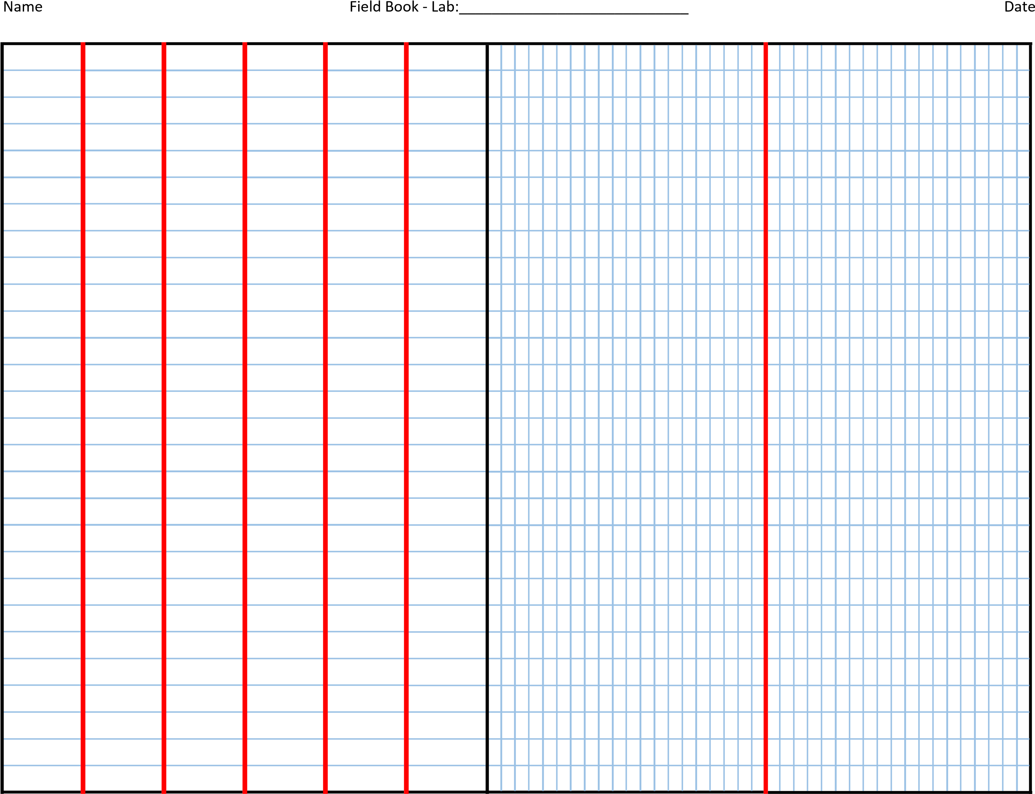
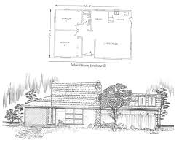
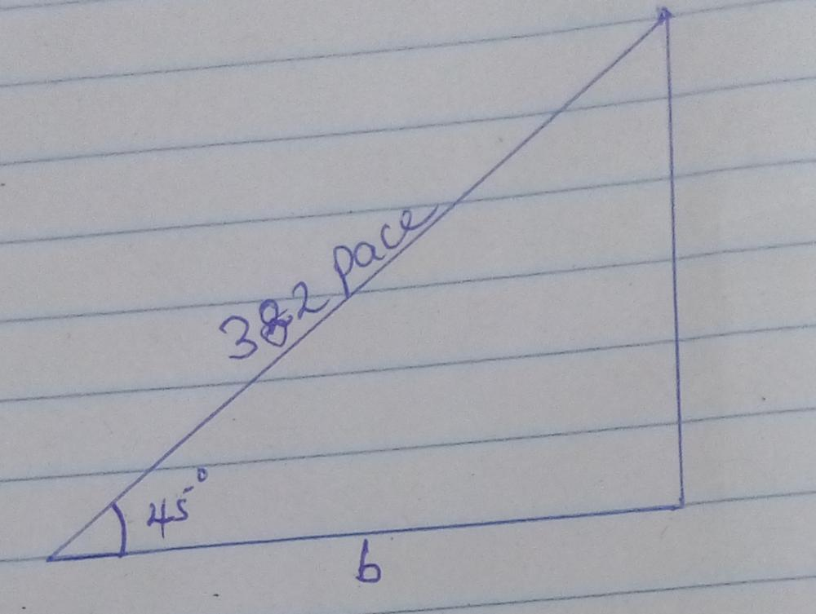
3) b/382 = cos 45 degrees
b = 382cos 45 degrees
=270.1147 paces
=270 paces

2) 149.5 × 2.35 = 351.325
=351 paces

- 547 × 2.35 = 1285.45
=1285 paces

Length of pace = distance/ number of paces
Distance = length of pace × average pace
Average number of paces = (41+43+44+40+45)/5 = 42.6
Individual pace length = 100/42.6 =2.35

